Topology Prelim (May 1995)

Problems
- Let $X$ be the subset of $R^{2}$ shown below. Is $X$ contractible?
- 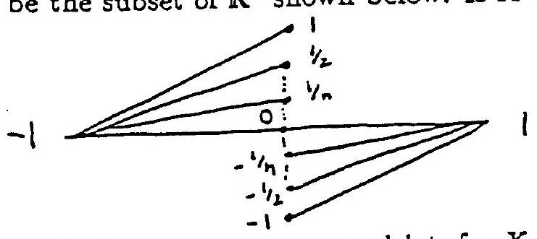
- Let $X$ and $Y$ be metric spaces and let $f:X×I→Y$ be a homotopy. Define $D(t)$, the diameter at time $t$, to be $\sup_{a,b∈X}\left\{d_{Y}(f(a,t),f(b,t))\right\}$,
  - Show that if $X$ is compact then $D$ is continuous.
  - Show that if we only assume $Y$ is compact then $D$ may not be continuous.
- Define an equivalence relation on $R$ by $x∼y$ iff $x-y∈Q$. Let $R/Q$ be the set of equivalence classes and give $R/Q$ the quotient topology with respect to the natural map $R→R/Q$. Is $R/Q$ compact? Is $R/Q$ Hausdorff?
- Compute the homology groups of $X$ where $X$ is the "half-solid" surface of genus $2$, i.e.
- 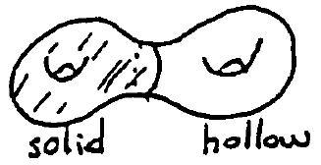
- Prove or disprove: every map $f:RP^{2}→RP^{2}$ has a fixed point.
- Define the natural map $π_{1}(X,*)→H_{1}(X)$. Show that it can have a kernel.
- Show that there is a map $f:S^{1}×S^{1}→S^{2}$ of degree $2$, that is, such that $f_{*}:H_{2}(S^{1}×S^{1})→H_{2}(S^{2})$ maps a generator to twice a generator.
- Show that there is a space $X$ with $π_{1}(X,*)=Z_{n}$.
- Let $p:(\tilde{X},{\overset{‾}{x}}_{0})→(X,x_{0})$ be a covering map and let $f:(Y,y_{0})→(X,x_{0})$ be a map. Assume $Y$ is path-connected and locally path-connected. State and prove necessary and sufficient conditions for the existence of a map $\tilde{f}:(Y,y_{0})→(\tilde{X},{\overset{‾}{x}}_{0})$ satisfying $p∘\tilde{f}=f$.

